Lab 07-Set Operations
Objective
Solving exercises from the textbook in chapter 2.1 & 2.2
Current Lab Learning Outcomes (LLO)
By completion of the lab, the students should be able to:
1. will understand set theory.
2. will be able to solve shorter/easier or longer / harder problems given in the textbook

Lab Requirements
Students allowed using their lecture notes in the lab in order to solve the exercises.
Lab Assessment
1- Divide students to groups and let them to solve the given example.
2- Discuss the answers with the groups and write on board the optimal solution.
Lab Description

- List the members of these sets.
a) {x | x is a real number such that x² = 1}
b) {x | x is a positive integer less than 12}
c) {x | x is the square of an integer and x < 100}
d) {x | x is an integer such that x² = 2}
Solution
- For each of these pairs of sets, determine whether the first is a subset of the second, the second is a subset of the first, or neither is a subset of the other.
a) the set of airline flights from NewYork to New Delhi, the set of nonstop airline flights from New York to New Delhi
b) the set of people who speak English, the set of people who speak Chinese
c) the set of flying squirrels, the set of living creatures that can fly

a) The second is a subset of the first, but the first is not a subset of the second b) Neither is a subset of the other. c) The first is a subset of the second, but the second is not a subset of the first

- For each of the following sets, determine whether 2 is an element of that set.
a) {x ∈ R | x is an integer greater than 1}
b) {x ∈ R | x is the square of an integer}
c) {2,{2}} d) {{2},{{2}}}e) {{2},{2,{2}}} f ) {{{2}}}

a) Yes b) No c) Yes d) No e) No f) No

- Find the truth set of each of these predicates where the domain is the set of integers.
a) P(x): x² < 3 b) Q(x): x² > x c) R(x): 2x + 1 = 0
a) {−1, 0, 1} b) Z−{0, 1} c) ∅

- Let A be the set of students who live within one mile of school and let B be the set of students who walk to classes. Describe the students in each of these sets.
a) A ∩ B b) A ∪ B c) A − B d) B − A

a) The set of students who live within one mile of school and walk to classes b) The set of students who live within one mile of school or walk to classes (or do both) c) The set of students who live within one mile of school but do not walk to classes d) The set of students who walk to classes but live more than one mile away from school

- Determine whether each of these statements is true or false.
a) 0 ∈ ∅ b) ∅ ∈ {0} c) {0} ⊂ ∅ d) ∅ ⊂ {0}
e) {0} ∈ {0} f ) {0} ⊂ {0} g) {∅} ⊆ {∅}
Solution
- What is the cardinality of each of these sets?
  - {a} b) {{a}} c) {a, {a}} d) {a, {a}, {a, {a}}}
Solution: a) 1 b) 1 c) 2 d) 3
- Find the power set of the sets where a and b are distinct elements
  - {a, b} b) {∅, {∅}}
Solution: a) {∅, {a}, {b}, {a, b}} b) {∅, {∅}, {{∅}}, {∅, {∅}}}
- How many elements does each of these sets have where a and b are distinct elements?
a) P({a, b, {a, b}}) 8
b) P({∅, a, {a}, {{a}}}) 16
c) P(P(∅)) 2 (Explanation: P(∅)={∅}. So, P(P(∅))={∅,{∅}})
- Let A = {a, b, c, d} and B = {y, z}. Find
  - A × B. b) B × A.
Solution: a) {(a, y), (b, y),(c, y), (d, y), (a, z), (b, z), (c, z), (d, z)} b) {(y, a), (y, b),(y, c), (y, d), (z, a), (z, b), (z, c), (z, d)}

- What is the Cartesian product A × B × C, where A is the set of all airlines and B and C are both the set of all cities in the United States? Give an example of how this Cartesian product can be used.

Solution: The set of triples (a, b, c), where a is an airline and b and c are cities. A useful subset of this set is the set of triples (a, b, c) for which a flies between b and c.
- Let A = {a, b, c, d, e} and B = {a, b, c, d, e, f, g, h}.Find
  - a) A ∪ B. b) A ∩ B. c) A − B. d) B − A.
Solution: a) {a,b,c,d,e,f,g,h} b) {a, b, c, d, e} c) {} d) {f,g,h}
- Let A = {0, 2, 4, 6, 8, 10}, B = {0, 1, 2, 3, 4, 5, 6}, Find |A∪B|. find the minimum number of elements in A∪B and maximum number of elements in A∪B
|A∪B|=|A|+|B|−|A∩B|
=6+7-4
9
A∪B is maximum or minimum according as |A∩B| is max or min.
case 1: |A∩B| is min ie |A∩B|=0
A∪B|=6+7-0
=13 so maximum number of elements in A∪B|is 13.
case 2: |A∩B| is max ie 4 , so min number of elements in A∪B is 9. the generalized solution is below

The Min number of elements in (A U B): we should assume that the intersection is the maximum which is
|A∩B|=|A| when A⊆B or |A∩B|=|B| when B⊆A . so
|A U B| = |B| or |A U B| =|A|

- Show that if A, B, and C are sets, then $A ∩ B ∩ C$ =A ∪ B ∪ C
  - by showing each side is a subset of the other side.
Solution: 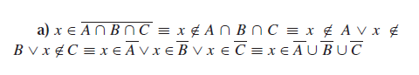

  - using a membership table.

- Let A, B, and C be sets. Show that
a) (A ∪ B) ⊆ (A ∪ B ∪ C).
b) (B − A) ∪ (C − A) = (B ∪ C) − A.
a)Solution: Let x be arbitrary.
x ∈ A ∪ B = (x ∈ A ∪ B) ∨ (x ∈ C)
= x ∈ (A ∪ B) ∪ C [Definition of ∪nion] Thus, since x ∈ A ∪ B → x ∈ (A ∪ B) ∪ C, it follows that
A ∪ B ⊆ A ∪ B ∪ C, by definition of subset

b)Proof. (B − A) ∪ (C − A)
= (B ∩ Ā ) ∪ (C ∩ Ā ) set difference
= (B ∪ C) ∩ Ā distibutive
= (B ∪ C) − A set difference

or

Let x ∈ (B − A) ∪ (C − A).
Then x ∈ (B − A) or x ∈ (C − A). If x ∈ (B − A), then x ∈ B and x A by definition of set difference
. If x ∈ (C − A), then x ∈ C and x A by definition of set difference.
Thus, x ∈ B or x ∈ C and x A. By definition of union, x ∈ (B∪C). By definition of set difference, if x ∈ (B ∪ C) and x A then x ∈ (B ∪ C) − A.

- Draw the Venn diagrams for each of these combinations of the sets A, B, and C.
  - a) A ∩ (B − C) b) (A ∩ B) ∪ (A ∩ C)
Solution:

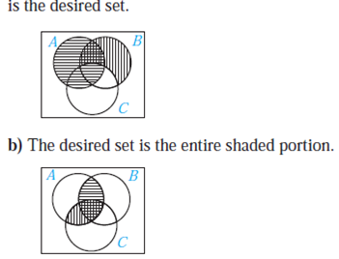
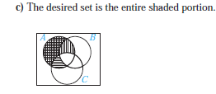
- Show that if A is a subset of a universal set U, then
a) A ⊕ A = ∅. b) A⊕ ∅ = A. c) A ⊕ U = = U.
Solution
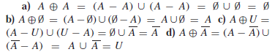

- Draw a Venn diagram that shows the following sample space and events:
S: all the integers from 1 to 30
P: prime numbers
M: multiples of 3
F: factors of 30
Solution
Write down the sample space and event sets
The sample space contains all the positive integers up to 30.
S={1;2;3;…;30}
The prime numbers between 1 and 30 are
P={2;3;5;7;11;13;17;19;23;29}
The multiples of 3 between 1 and 30 are
M={3;6;9;12;15;18;21;24;27;30}
The factors of 30 are
F={1;2;3;5;6;10;15;30}
Draw the outline of the Venn diagram
There are 3 events, namely P, M and F, and the sample space, S. Put this information on a Venn diagram:
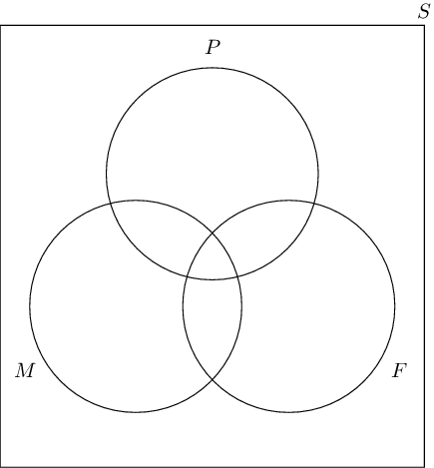
Place the outcomes in the appropriate event sets
